TB38M16 Wiring Manual
Ver 1.0

Contents
1. Function Brief 1
2. Main Interface of TB38M16 2
2.1 TB38M16 Interface Diagram 2
2.2 Pin Definition of TB38M16 Interface Board’s Functional Interfaces 2
3. Appendix: Basic Connection 3
3.1 DIP1 Power Port 3
3.2 DIP1 Network Interface 3
3.3 DIP3 Audio Output 4
3.4 DIP4 Audio Mic Input 4
3.5 DIP5 TF Card, FPC Mount 4
3.6 DIP6 Extended interface 5
3.6 DIP6 Supported lamp board connection method 5

If you need personalized IP camera products, board level network video module is your best choice. It is easy for you to manufacture personalized IR IP camera, you just need to open camera housing, fix the network video module and connect them

2. Main Interface of TB38M16

2.1 TB38M16 Interface Diagram

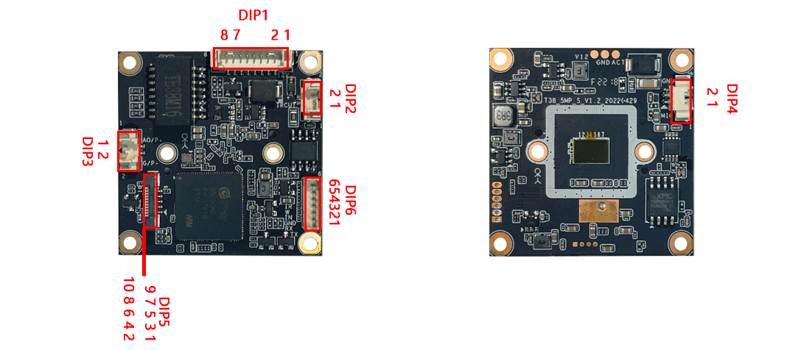

Veneer front Interface Figure Veneer behind Interface Figure

2.2 Pin Definition of TB38M16 Interface Board’s Functional Interfaces
DIP1：Power input and network interface
1 | DC12V
2 | GND
3 | RJ1
4 | RJ2
5 | RJ3
6 | RJ6
7 | RST
8 | Network indicator light
DIP2: IR-CUT Interface
1 | IR-CUT connection port 1
2 | IR-CUT connection port 2
DIP3：Audio output interface
1 | Audio output
2 | GND
DIP4：Audio Mic Input
1 | Audio Mic input
2 | GND
DIP5：TF Card, FPC Mount
1 | SDIO1_D2
2 | SDIO1_D2
3 | SDIO1_CMD
4 | 3V3
5 | SDIO1_CLK
6 | GND
7 | SDIO1_D0
8 | SDIO1_D1
9 | SD_DET
10 | SW_RST
DIP6：Extended interface
1 | Alarm IO
2 | AUART_RX
3 | GND
4 | Hard light-sensitive input
5 | PWM white light board
6 | PWM infrared light board

3. Appendix: Basic Connection

3.1 DIP1 Power Port
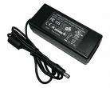
2 3 4 5 6 78

DIP1
12V
GND
12V/2A
Power Supply

3.2 DIP1 Network Interface
Example 1: Method of directly connect to network cable

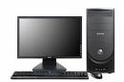
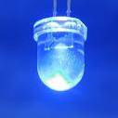
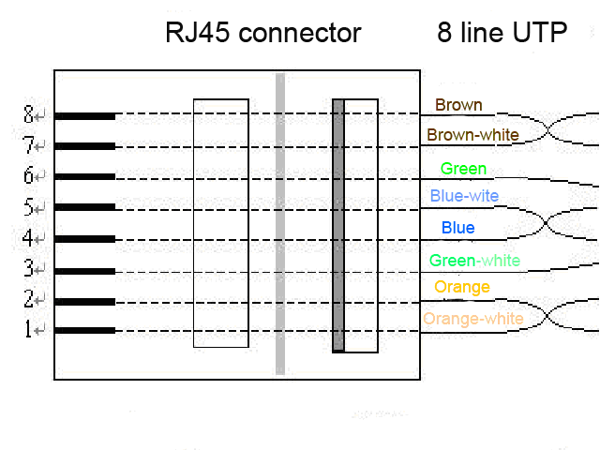
Green-white
3 4 5 6 7 8
Orange
Orange-white
Green
6
3
1
2
GND
Pick-up RST Reset Button

Example 2: Lead up to an RJ45 seat, then use the method of cross-wire and PC connection
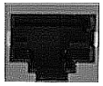
1.TX+
2.TX-
3.RX+
4.NU
5.NU
6.RX-
7.NU
8.NU
RJ45 Pin
3 4 5 6 7 8
DIP1
Cross line

\

3.3 DIP3 Audio Output

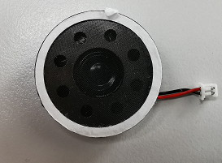

1 2
DIP3
Audio Output
Audio ground
Audio output: load impedance R, power P, without grounding
R | P
8Ω | 2w

3.4 DIP4 Audio Mic input
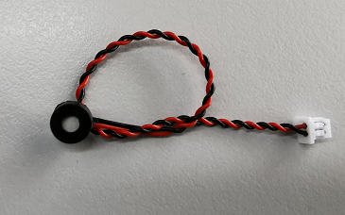

1 2
Audio Mic input
DIP4
Audio ground

3.5 DIP5 TF Card, FPC Mount
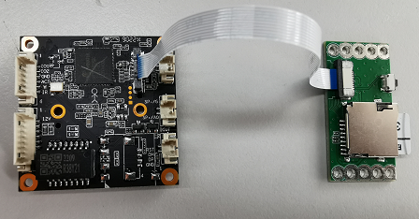

【Note: the length of FPC line is recommended to be less than or equal to 10cm】

3.6 DIP6 Extension interface
1. Alarm IO
2. AUART_RX
4. Hard light-sensitive input
5. PWM white light board
6. PWM infrared light board

Alarm IO
1 2 3 4 5 6
AUART_RX

Hard light-sensitive input

PWM white light board

PWM infrared light board

3.6 DIP6 Supported lamp board connection method
<1>When connecting PWM infrared lamp board

5 6

Output intelligent signal, control infrared light

<2>When connecting PWM white light board

5 6

Output intelligent signal, control white light

<3>When connecting the PWM infrared white light board

5 6
Output intelligent signal, control white light

Output intelligent signal, control infrared light

